Huan Shiuan Huang

CMSC 204

Assignment 2

10/2/2020

Learning Experience

What I learn in this project is that how to making stack and queue, even there are already have stack and queue interface in Java API. Review the exception from 203.

What I struggle with is how to find an error from my code. I spend many time in fixing my program.

I will also do my best in the next project.

UML

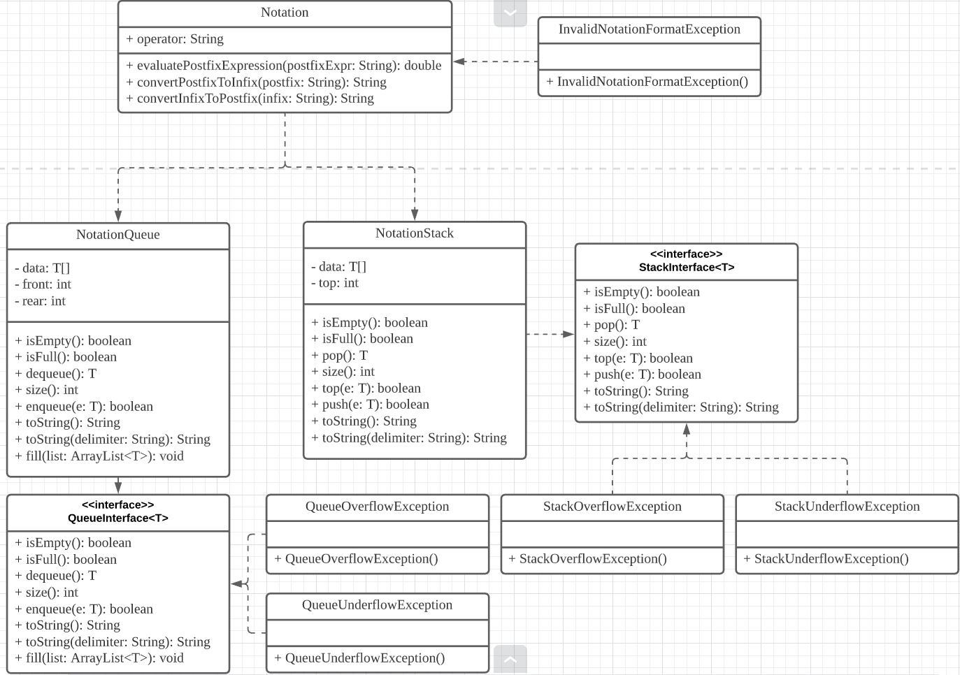

GitHub

